Adders. Simple ALU
- Half Adder
- Full Adder
- Constructing 4 bit adder
- ALU does several operations
- General ALU structure
- Timing diagram of adder
- Overflow logic
Textbook P&H: Ch. 4.5, Appendix B, http://www.play-hookey.com

- Goal – Teach students how to create ALU.
- Learning outcome - by the end of this class the students should be able to create an ALU with the given amount of bits and with overflow detection logic.

Adders
A key requirement of digital computers is the ability to use logical functions to perform arithmetic operations. The basis of this is addition; if we can add two binary numbers, we can just as easily subtract them, or get a little fancier and perform multiplication and division. How, then, do we add two binary numbers?

Adding two bits. Half Adders

Let's start by adding two binary bits. Since each bit has only two possible values, 0 or 1, there are only four possible combinations of inputs. These four possibilities, and the resulting sums, are:
That fourth line indicates that we have to account for two output bits when we add two input bits: the sum and a possible carry. Let's set this up as a truth table with two inputs and two outputs, and see where we can go from there. | 0 + 0 = 0  0 + 1 = 1  1 + 0 = 1  1 + 1 = 10

INPUTS |  | OUTPUTS |  | Well, this looks familiar, doesn't it? The Carry output is a simple AND function, and the Sum is an Exclusive-OR. Thus, we can use two gates to add these two bits together. The resulting circuit is shown below.  Sum = A’B + AB’ = A ⊕ B  Carry = AB
A | B | CARRY | SUM
0 | 0 | 0 | 0
0 | 1 | 0 | 1
1 | 0 | 0 | 1
1 | 1 | 1 | 0

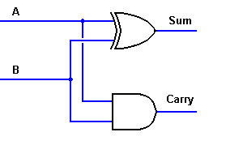 Half adder | OK, we've got a good start on this circuit. However, we're not done yet. In a computer, we'll have to add multi-bit numbers together. If each pair of bits can produce an output carry, it must also be able to recognize and include a carry from the next lower order of magnitude. This is the same requirement as adding decimal numbers -- if you have a carry from one column to the next, the next column has to include that carry. We have to do the same thing with binary numbers, for the same reason. As a result, the circuit to the left is known as a "half adder," because it only does half of the job. We need a circuit that will do the entire job.

Adding two bits and the carry bit. One Position(bit) Full Adder

To construct a full adder circuit, we'll need three inputs and two outputs.

Since we'll have both an input carry and an output carry, we'll designate them as C_{IN} and C_{OUT}. At the same time, we'll use S to designate the final Sum output. The resulting truth table is shown to the right.  This is looking a bit messy. It looks as if C_{OUT} may be either an AND or an OR function, depending on the value of A, and S is either an XOR or an XNOR, again depending on the value of A. Looking a little more closely, however, we can note that the S output is actually an XOR between the A input and the half-adder SUM output with B and C_{IN} inputs. Also, the output carry will be true if any two or all three inputs are logic 1.  What this suggests is also intuitively logical: we can use two half-adder circuits. The first will add A and B to produce a partial Sum, while the second will add C_{IN} to that Sum to produce the final S output. If either half-adder produces a carry, there will be an output carry. Thus, C_{OUT} will be an OR function of the half-adder Carry outputs. | INPUTS |  |  | OUTPUTS
 | A | B | C_{IN} | C_{OUT} | S
 | 0 | 0 | 0 | 0 | 0
 | 0 | 0 | 1 | 0 | 1
 | 0 | 1 | 0 | 0 | 1
 | 0 | 1 | 1 | 1 | 0
 | 1 | 0 | 0 | 0 | 1
 | 1 | 0 | 1 | 1 | 0
 | 1 | 1 | 0 | 1 | 0
 | 1 | 1 | 1 | 1 | 1

S = A’B’C_{in}+ A’BC_{in}’ + AB’C_{in}’ + ABC_{in} = C_{in}(A’B’ + AB) + C_{in}’ (AB’+ A’B) = C_{in}(A’B’ + AB)’’ + C_{in}’ (AB’+ A’B) = C_{in}(A ⊕ B)’ + C_{in}’ (A ⊕ B) = (A ⊕ B) ⊕ C_{in}
C_{out} = A’BC_{in}+ AB’C_{in} + ABC_{in}’ + ABC_{in} = C_{in}(A’B + AB’) + AB (C_{in} + C_{in}’) = C_{in}(A’B + AB’) + AB (1) =
C_{in}(A ⊕ B) + AB
Taking in account that the intermediate Sum and Carry for Half Adder we already know:
Sum = A ⊕ B
Carry = AB

the resulting full adder circuit will be the one shown below.

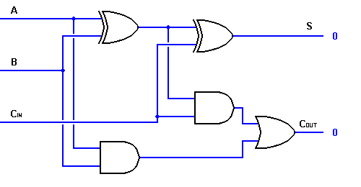

Constructing 4 bit adder based on one bit adder

The circuit above is really too complicated to be used in larger logic diagrams, so a separate symbol, shown to the right, is used to represent a one-bit full adder. In fact, it is common practice in logic diagrams to represent any complex function as a "black box" with input and output signals designated. It is, after all, the logical function that is important, not the exact method of performing that function. | 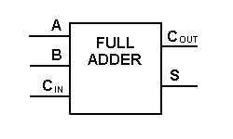

Now we can add two binary bits together, accounting for a possible carry from the next lower order of magnitude, and sending a carry to the next higher order of magnitude. To perform multibit addition the way a computer would, a full adder must be allocated for each bit to be added simultaneously. Thus, to add two 4-bit numbers to produce a 4-bit sum (with a possible carry), you would need four full adders with carry lines cascaded, as shown to the right. For two 8-bit numbers, you would need eight full adders, which can be formed by cascading two of these 4-bit blocks. By extension, two binary numbers of any size may be added in this manner.  It is also quite possible to use this circuit for binary subtraction. If a negative number is applied to the B inputs, the resulting sum will actually be the difference between the two numbers.  In a modern computer, the adder circuitry will include the means of negating one of the input numbers directly, so the circuit can perform either addition or subtraction on demand. Other functions are commonly included in modern implementations of the adder circuit, especially in modern microprocessors. | 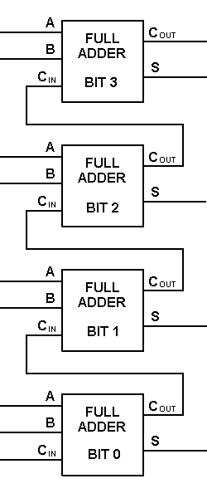

ALU does several operations

The logical operations are easiest, because they map directly onto the hardware components.
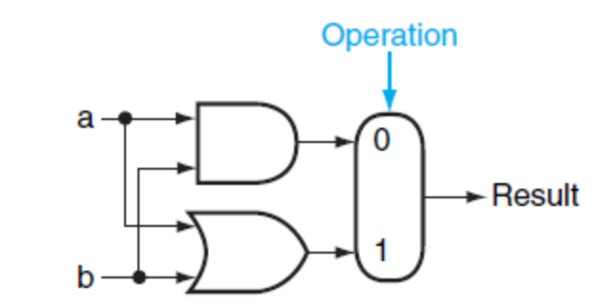

FIGURE C.5.1 The 1-bit logical unit for AND and OR.

The 1-bit logical unit for AND and OR looks like Figure C.5.1.

The multiplexor on the right then selects a AND b or a OR b, depending on whether the value of Operation is 0 or 1.

The line that controls the multiplexor is shown in color to distinguish it from the lines containing data. Notice that we have renamed the control and output lines of the multiplexor to give them names that reflect the function of the ALU.

Figure C.5.6 shows a 1-bit ALU derived by combining the adder with the earlier components. Sometimes designers also want the ALU to perform a few more simple operations, such as generating 0. The easiest way to add an operation is to expand the multiplexor controlled by the Operation line and, for this example, to connect 0 directly to the new input of that expanded multiplexor.
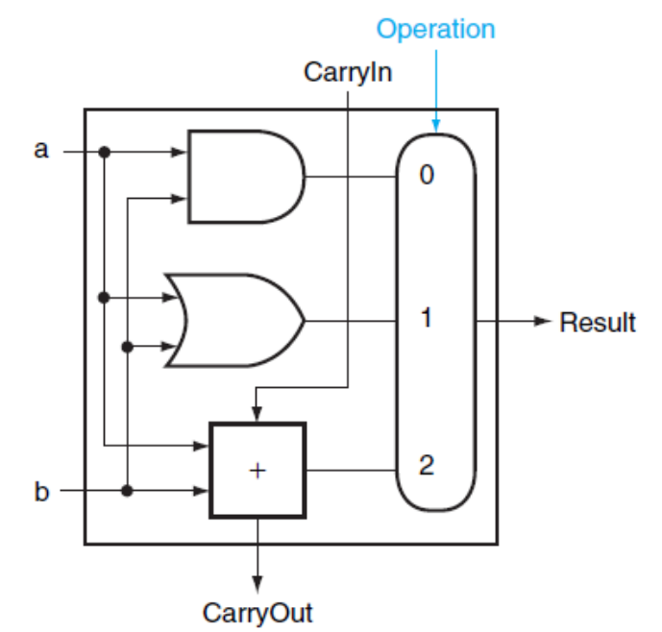

FIGURE C.5.6 A 1-bit ALU that performs AND, OR, and addition

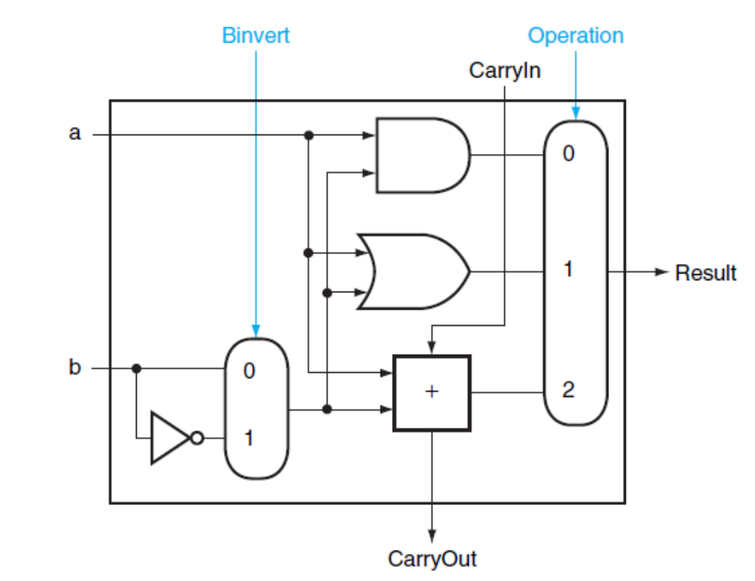
FIGURE C.5.8. A 1-bit ALU that performs AND, OR, and addition on a and b or a and b’
By selecting
__
b (Binvert = 1) and setting CarryIn to 1 in the least significant bit of the ALU, we get two’s complement subtraction of b from a instead of addition of b to a.

General ALU structure
Let’s see how works created by us Adder in simple ALU together with several registers and overflow control logic.
This model is general enough to show the function of most of different ALU s.
Control Unit provides necessary sequence of signals to control ALU to do operations in correct sequence.
- First ALU gets the “Allow A” and “Allow B” signals which open Gates A and Gates B thus allowing both A and B operands to go through that gates to the inputs of Adder.
- During some time (the adding time) A and B operands are added and the Sum appears on output together with the Carry out bits which are the basis for creating the overflow condition.
- Next the control unit gives two signals Take Sum and Take Overflow.
- The ready Sum goes to the Sum Register through open “Sum Gates” to be used further. The Carry Out bits are analyzed by “Overflow Logic” and cause or not cause the Overflow State in interruption register (particularly in MIPS the Cause Register’s appropriate bits).
- As the Sum and the Overflow Condition are taken then Control Unit now can freely remove all signals as from input as well as output gates.
- Next time the same cycle will be done for next two operands.
General Purpose Registers

Overflow bit in Cause Register

Take Overflow

Allow
A

Overflow logic
Register
A
Gates A
A input
Sum Gates

Adder
Sum
Register

Register
B
B input
Sum on output

Take Sum

Gates B

Allow
B

Simple ALU

Combinational logic, gates
Registers

Operands (Data)

Sum (Data)

Control Unit signals

Overflow signals

Below is shown the schematic of part of ALU. Our knowledge now is enough to create such a unit and understand how it works.

Allow
A
Allow
B
Take the
Sum
Full
Adder
Bit 3
So
S
Ai
Bi
Cin
Cout
&
&
&
A
B

Full
Adder
Bit 2
So
S
Ai
Bi
Cin
Cout
&
&
&
A
B

Full
Adder
Bit 1
So
S
Ai
Bi
Cin
Cout
&
&
&
A
B

&

A

Ai

Cout

Full

Adder

Bit 0

Bi

B

S
&

So

Cin
&

The timing diagram of above schematic is shown below. ALU delay time is the minimal time we can repeat the sequence of operations in this circuit. So it is the minimal time of ALU cycle.

ALU delay (Cycle)

Allow A

Allow B

A

B

Ai

Bi

Sout

Cout

Take Sum

S

Take Overflow

Set Overflow bit

Below is the description how the overflow is controlled particularly for two instructions cases – “add” and “addu”. In similar situations one of them will not cause the overflow (addu) the other has to cause (add).
Let’s remember the overflow condition:
The result is correct if the carry into the high order column is the same as the carry out of the high order column. The carry bits can both be zero or both be one.

Cout3  a | Cout2  b | Add  c | Overflow  Y
0  0  0  0  1  1  1  1 | 0  0  1  1  0  0  1  1 | 0  1  0  1  0  1  0  1 | 0  0  0  1  0  1  0  0

Y=a’bc + ab’c = c (a’b+ab’)

 | A’ |  | A
 |  |  | 1 |  | B’
 |  | 1 |  |  | B
 | C’ | C |  | C’

&
1

a – Cout 3

&

b – Cout 2

c – Add

&
Overflow

Y=a’bc + ab’c = c (a’b+ab’)

Y=a’bc + ab’c = c (a’b+ab’)

⊕
a – Cout 3

b – Cout 2

&
Overflow

c – Add

&
Take Overflow

Set Overflow
Bit

